**Project Description**

Project Title: **Two-wheeler insights using user review (RPA – Analytix – Data Visualization)**

Team Name : Cookie_RPA

Team Leader : Ranjith S

Team Member : Shaik Mastan Babu

**Abstract :**

Purchasing a bike is one of the most difficult choice to make cause right now there are many bikes with many advance features available. A customer needs to know the full-scale details of the bike which an individual is willing to buy. This concept of the providing details for the customer on his dream bike is the base of this project. This Project is very simple to use, all the customer must do is to send a mail with his selected bike name and city he lives. That’s it he in-return receive a dashboard with all details graphically represented. This project uses the Automation Anywhere A2019 for the automation process, Microsoft Azure for the analysis and Tableau for the Visualization.

**Project Components :**

There are three different Software Components used in the development of this project

1. Automation Anywhere A2019
2. Microsoft Azure(Text Analysis)
3. Tableau

**Components Description:**

1. **Automation Anywhere A2019**

Automation Anywhere Community A2019 is the world’s first web-based, cloud-native Robotic Process Automation (RPA) platform, making it easier than ever to automate business processes.

With a suite of drag-and-drop tools, Community A2019 lets you automate nearly any process you can think of without installing any software. Now, it’s virtually effortless to get up to speed on Community A2019, thanks to the free Automation Anywhere [Community Edition](https://www.automationanywhere.com/blog/product-insights/reality-one-rpa-platform-for-all-market-segments) and targeted courses available at [Automation Anywhere University](https://university.automationanywhere.com/enterprise-a2019/) (AAU). No coding experience required.

1. **Microsoft Azure (Text Analysis)**

Microsoft Azure is a platform as a service (PaaS) solution for building and hosting solutions using Microsoft’s products in their data centers. It is a comprehensive suite of cloud products that allow users to create enterprise-class applications without having to build out their own infrastructure.

The Azure Service Platform is comprised of three cloud centric products: Windows Azure, SQL Azure and Azure App Fabric controller. These are in addition to the application hosting infrastructure facility.

The Text Analytics API is a cloud-based service that provides advanced natural language processing over raw text, and includes four mail functions:

* Sentiment Analysis
* Key Phrase Extraction
* Language Detection
* Named Entity Recognition

1. **Tableau**

Tableau is a powerful and fastest growing data visualization tool used in the Business Intelligence Industry. It helps in simplifying raw data into the very easily understandable format.

**Idea Brief :**

A general customer at every purchase will first think of product’s current status in the market and he will justify it by going through the reviews or feedback given by the previously consumers and he will look through the some of the key points like stability, comfort, prising and etc. After going through all of this he will take a decision on the product.

Currently the marketing staff are providing all false data and reference to the customers and making them to purchase the low-quality goods which results in the customer’s lose. To help the customer at this point we were working on a solution for it. For this we started to get the information from very liable source and filter it out and give it provide it in an easy understandable format to the customers.

**Process Description:**

Bot will function is three stages

1. Bot triggering
2. Data Scrapping
3. Data Preparation
4. Report Generation
5. **Bot Triggering**

Bot start with a mail trigger functional in the automation anywhere to a Mail Id ([ranjithmca31@gmail.com](mailto:ranjithmca31@gmail.com)) with a specific Mail Subject as the “**Bike insights”**  and the Mail body should have a two data 1. Vehicle Name 2. Location

Mail structure will be like

Mail to : [ranjithca31@gmail.com](mailto:ranjithca31@gmail.com)

Mail Subject : Bike insights

Mail Body : 1.Vehicle Name

2.Location

1. **Data Scraping**

Bot will read the data from the Mail and will proceed for the Data Scraping Stage. Here in this Stage bot will Browse to the website and will start to capture all the data from the website relatively given on the bike in the website. Later it will feed data to the Microsoft Azure Services

1. **Data Preparation**

Here in the Data Preparation bot will using the Sentimental Analysis Service of the Microsoft Azure Text Analysis. It will rate the review obtained from the website and will save all the data in the Excel.

1. **Report Generation**

The data saved in the excel will used as input for the Report generation which is a dashboard generated by using the tableau software. After the Report is successfully generated the bot will send the report the customer who has requested for the details

Data Provided in the Report are

1. Overall Rating
2. Top 5 Positive Reviews
3. Top 5 Negative Reviews
4. Rating Reviews
5. Similar bikes
6. Feature
7. Engine & Transmission
8. Dimension & chassis
9. Break, wheel and Suspension
10. Variants
11. Highlights
12. Good Things
13. Could be better
14. About
15. Price in nearby Cities
16. Showrooms & Contacts

Screenshot of the dashboard are given below

1. **Insights Dashboard**

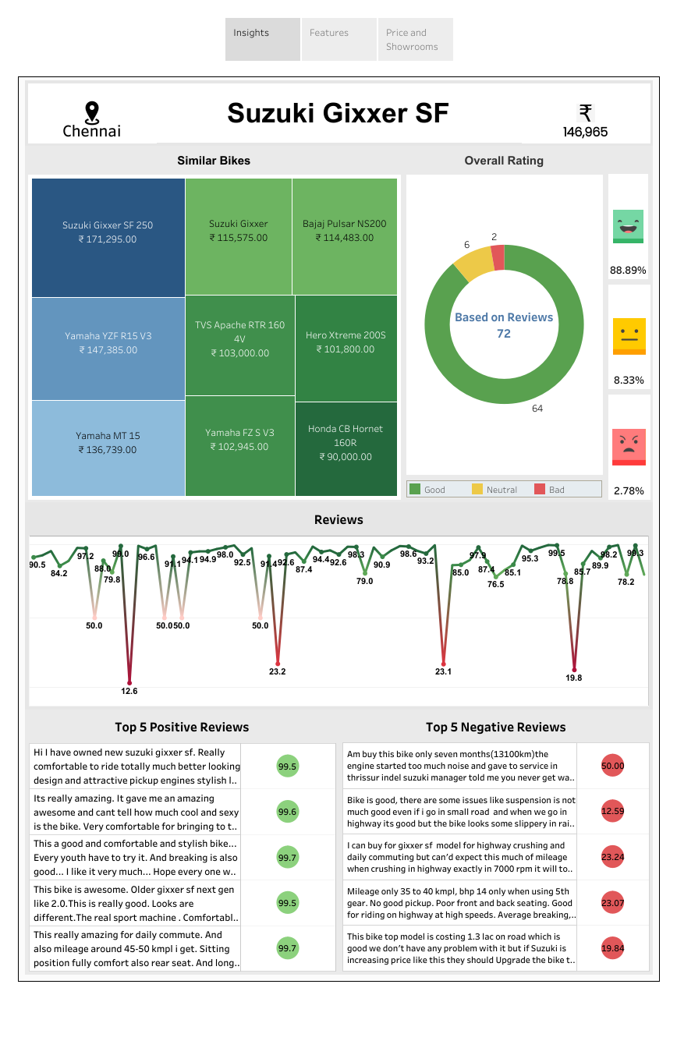

1. **Features Dashboard**

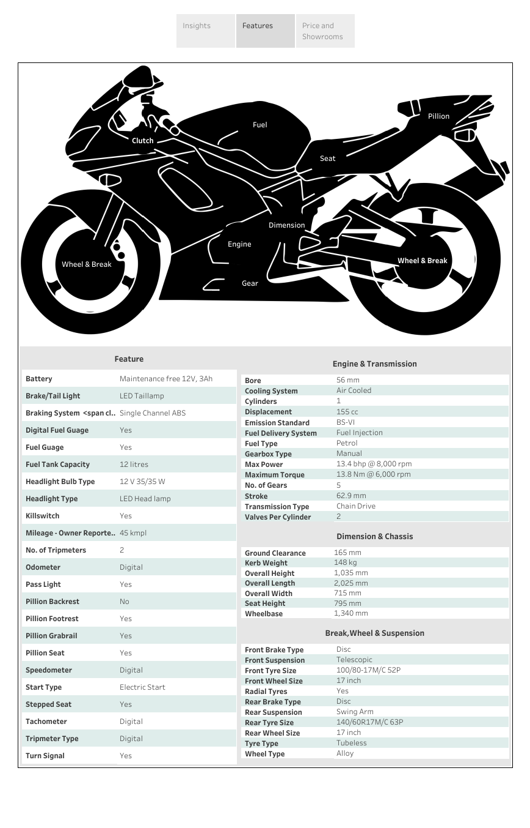

1. **Price and Showrooms**

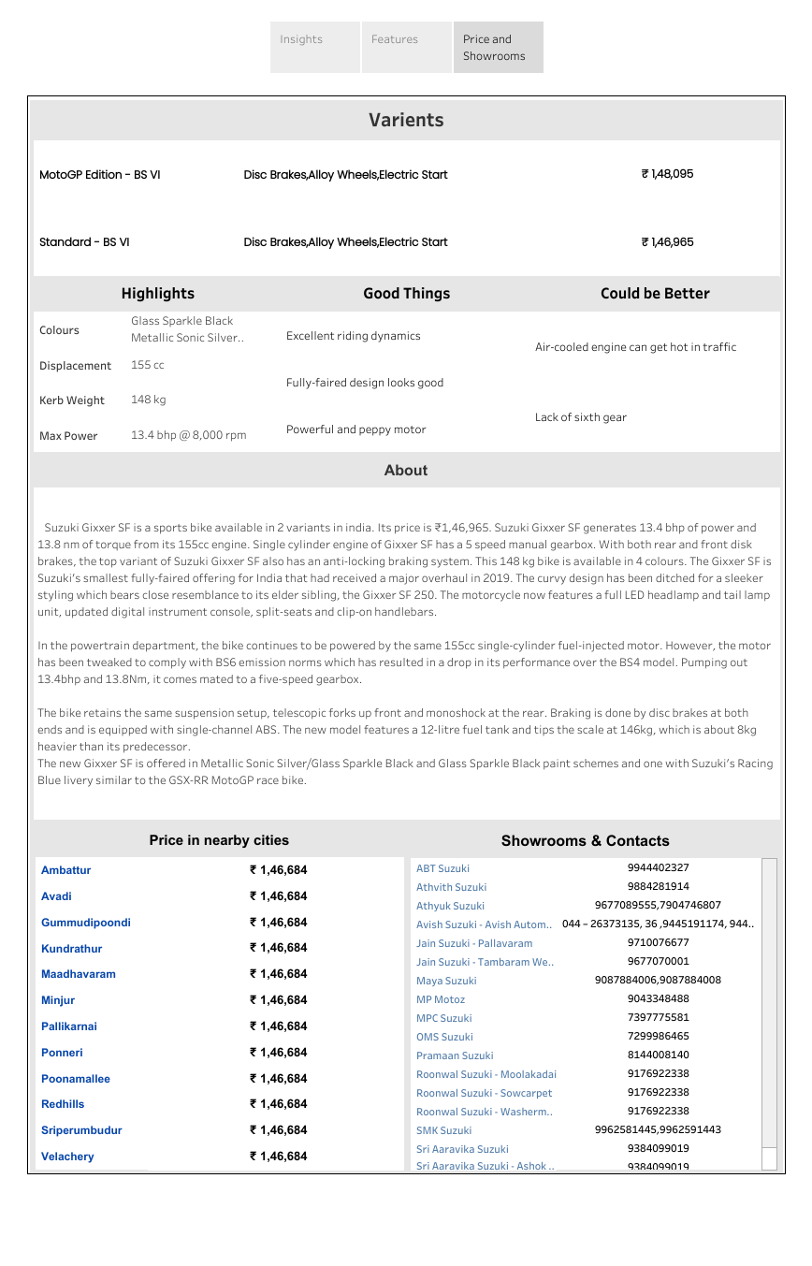

**Conclusion :**

Here with this implementation we could able to conclude that the Automation Anywhere A2019 and Microsoft Azure Text Analysis were used for the creation of the Dashboard in the Tableau which in-return helps the customer to get full-scale details about their dream bike and help them easily understand all the details about bike